DATABASE DESIGN (STUDENT CRM)

1.USERS

CREATE TABLE users (
user_id INT PRIMARY KEY AUTO_INCREMENT,
name VARCHAR(100) NOT NULL,
email VARCHAR(100) UNIQUE,
phone VARCHAR(15),
role ENUM('admin','counselor','manager') NOT NULL,
password_hash VARCHAR(255) NOT NULL,
is_active BOOLEAN DEFAULT TRUE,
created_at TIMESTAMP DEFAULT CURRENT_TIMESTAMP
);

2. COURSES

CREATE TABLE courses (
course_id INT PRIMARY KEY AUTO_INCREMENT,
course_name VARCHAR(150) NOT NULL,
duration VARCHAR(50),
fees DECIMAL(10,2) NOT NULL,
is_active BOOLEAN DEFAULT TRUE
);

3. SOURCES

CREATE TABLE sources (
source_id INT PRIMARY KEY AUTO_INCREMENT,
source_name VARCHAR(100) NOT NULL
);

4. ENQUIRIES

CREATE TABLE enquiries (
enquiry_id INT PRIMARY KEY AUTO_INCREMENT,
student_name VARCHAR(100) NOT NULL,
email VARCHAR(100),
phone VARCHAR(15) NOT NULL,
city VARCHAR(50),
course_id INT,
source_id INT,
status ENUM('new','contacted','interested','not_interested','closed','converted') DEFAULT 'new',
assigned_to INT,
created_at TIMESTAMP DEFAULT CURRENT_TIMESTAMP,

FOREIGN KEY (course_id) REFERENCES courses(course_id),
FOREIGN KEY (source_id) REFERENCES sources(source_id),
FOREIGN KEY (assigned_to) REFERENCES users(user_id)
);

5. CALL RECORDS

CREATE TABLE call_records (
call_id INT PRIMARY KEY AUTO_INCREMENT,
enquiry_id INT NOT NULL,
counselor_id INT,
call_time DATETIME DEFAULT CURRENT_TIMESTAMP,
call_status ENUM('connected','not_reachable','busy','no_response'),
remarks TEXT,
FOREIGN KEY (enquiry_id) REFERENCES enquiries(enquiry_id),
FOREIGN KEY (counselor_id) REFERENCES users(user_id)
);

6. FOLLOW-UPS
CREATE TABLE followups (
followup_id INT PRIMARY KEY AUTO_INCREMENT,
enquiry_id INT NOT NULL,
counselor_id INT,
followup_date DATE NOT NULL,
status ENUM('pending','completed','missed'),
remarks TEXT,
FOREIGN KEY (enquiry_id) REFERENCES enquiries(enquiry_id),
FOREIGN KEY (counselor_id) REFERENCES users(user_id)
);

7. ADMISSIONS
CREATE TABLE admissions (
admission_id INT PRIMARY KEY AUTO_INCREMENT,
enquiry_id INT UNIQUE,
course_id INT,
admission_date DATE DEFAULT CURRENT_DATE,
total_fees DECIMAL(10,2),
discount DECIMAL(10,2) DEFAULT 0,
final_fees DECIMAL(10,2),
FOREIGN KEY (enquiry_id) REFERENCES enquiries(enquiry_id),
FOREIGN KEY (course_id) REFERENCES courses(course_id)
);

8. PAYMENTS
CREATE TABLE payments (
payment_id INT PRIMARY KEY AUTO_INCREMENT,
admission_id INT NOT NULL,
amount DECIMAL(10,2) NOT NULL,
payment_date DATETIME DEFAULT CURRENT_TIMESTAMP,
payment_mode ENUM('cash','card','upi','netbanking'),
status ENUM('success','pending','failed'),
FOREIGN KEY (admission_id) REFERENCES admissions(admission_id)
);

9. STATUS HISTORY
Tracks full lifecycle (very important in real CRM)
CREATE TABLE enquiry_status_history (
id INT PRIMARY KEY AUTO_INCREMENT,
enquiry_id INT,
old_status VARCHAR(50),
new_status VARCHAR(50),
changed_by INT,
changed_at TIMESTAMP DEFAULT CURRENT_TIMESTAMP,
FOREIGN KEY (enquiry_id) REFERENCES enquiries(enquiry_id),
FOREIGN KEY (changed_by) REFERENCES users(user_id)
);

10. TASKS / REMINDERS
CREATE TABLE tasks (
task_id INT PRIMARY KEY AUTO_INCREMENT,
user_id INT,
enquiry_id INT,
task_date DATE,
description TEXT,
status ENUM('pending','completed'),
FOREIGN KEY (user_id) REFERENCES users(user_id),
FOREIGN KEY (enquiry_id) REFERENCES enquiries(enquiry_id)
);

RELATIONSHIP SUMMARY
- User → Enquiries (1:M)
- Enquiry → Call Records (1:M)
- Enquiry → Follow-ups (1:M)
- Enquiry → Admission (1:1)
- Admission → Payments (1:M)
- Course → Enquiries / Admissions (1:M)
- Source → Enquiries (1:M)

Class Diagram

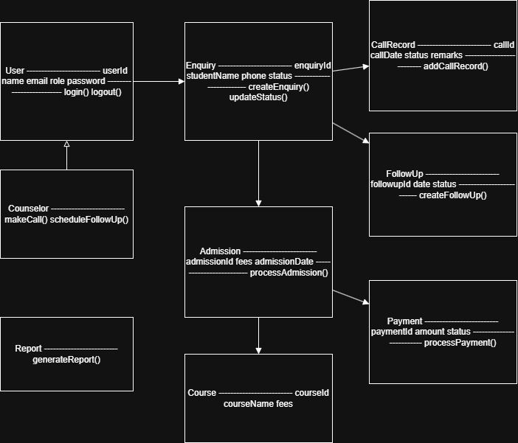

User
User
------------------
userId
name
email
role
password

📄 Enquiry
Enquiry
------------------
enquiryId
studentName
phone
status

📞 CallRecord
CallRecord
------------------
callId
callDate
status
remarks

📅 FollowUp
FollowUp
------------------
followupId
date
status

🎓 Admission
Admission
------------------
admissionId
fees
admissionDate

💳 Payment
Payment
------------------
paymentId
amount
status

📘 Course
Course
------------------
courseId
courseName
fees

